1. Create the HTML form given below. Attach the Output and code.

**Task#1:**

* Index.html

|  |
| --- |
| **<!DOCTYPE html>**  **<html lang="en">**  **<head>**  **<meta charset="UTF-8">**  **<meta http-equiv="X-UA-Compatible" content="IE=edge">**  **<meta name="viewport" content="width=device-width, initial-scale=1.0">**  **<title>LAB</title>**  **</head>**  **<body bgcolor="lightblue">**  **<h1>TASK#1:</h1>**  **<br></br>**  **<form>**  **<label>Email:</label>**  **<input type="email" id="email" value="email">**  **<br></br>**  **<label>Gender:</label>**  **<input type="radio" id="male" value="male">**  **<label>Male</label>**  **<input type="radio" id="female" value="female">**  **<label>Female</label>**  **<br></br>**  **<label>Message:</label>**  **</br>**  **<textarea rows="5" cols="50"></textarea>**  **<br></br>**  **<input type="checkbox" id="checkbox" value="checkbox">**  **<label>Subscribe?</label>**  **<br></br>**  **<input type="submit" id="submit" value="submit">**  **<br></br>**  **</form>**  **</br>**  **</body>**  **</html>** |

**Output:**

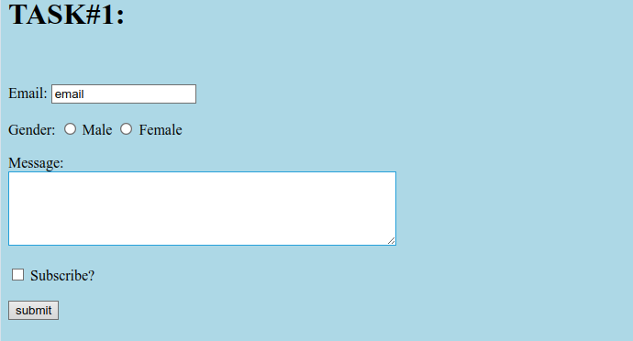

2. Create your Time Table. Attached the output and the code

**Task#2:**

* **Index.html**

|  |
| --- |
| **<!DOCTYPE html>**  **<html lang="en">**  **<head>**  **<meta charset="UTF-8">**  **<meta name="viewport" content="width=device-width, initial-scale=1.0">**  **<title>Student Registration Form</title>**    **</head>**  **<body bgcolor="lightblue">**  **<div class="container">**  **<h2>Student Registration Form</h2>**  **<form>**  **<label>First Name: <input type="text" maxlength="30"></label>**  **<label>Last Name: <input type="text" maxlength="30"></label>**  **<label>Date of Birth:**  **<select><option>Day</option></select>**  **<select><option>Month</option></select>**  **<select><option>Year</option></select>**  **</label>**  **<label>Email ID: <input type="email"></label>**  **<label>Mobile Number: <input type="text" maxlength="10"></label>**  **<label>Gender:**  **<input type="radio" name="gender"> Male**  **<input type="radio" name="gender"> Female**  **</label>**  **<label>Address: <textarea></textarea></label>**  **<label>City: <input type="text" maxlength="30"></label>**  **<label>Pin Code: <input type="text" maxlength="6"></label>**  **<label>State: <input type="text" maxlength="30"></label>**  **<label>Country: <input type="text" value="India" readonly></label>**  **<label>Hobbies:**  **<input type="checkbox"> Drawing**  **<input type="checkbox"> Singing**  **<input type="checkbox"> Dancing**  **<input type="checkbox"> Sketching**  **<input type="text" placeholder="Others">**  **</label>**  **<label>Qualification:**  **<table border="1" width="100%">**  **<tr>**  **<th>Sl.No.</th><th>Examination</th><th>Board</th><th>Percentage</th><th>Year of Passing</th>**  **</tr>**  **<tr><td>1</td><td>Class X</td><td><input type="text"></td><td><input type="text"></td><td><input type="text"></td></tr>**  **<tr><td>2</td><td>Class XII</td><td><input type="text"></td><td><input type="text"></td><td><input type="text"></td></tr>**  **<tr><td>3</td><td>Graduation</td><td><input type="text"></td><td><input type="text"></td><td><input type="text"></td></tr>**  **<tr><td>4</td><td>Masters</td><td><input type="text"></td><td><input type="text"></td><td><input type="text"></td></tr>**  **</table>**  **</label>**  **<label>Courses Applied For:**  **<input type="checkbox"> BCA**  **<input type="checkbox"> B.Com**  **<input type="checkbox"> B.Sc**  **<input type="checkbox"> B.A**  **</label>**  **<div class="btn-group">**  **<button type="submit">Submit</button>**  **<button type="reset">Reset</button>**  **</div>**  **</form>**  **</div>**  **</body>**  **</html>** |

**Output:**

